quiz title: Sample quiz from a Word file.
quiz description: This is a sample quiz created from a Word file.
shuffle answers: true
show correct answers: true
one question at a time: true
GROUP
Group title: Name of Group - This will be the name of the Item Bank on Canvas
pick: 1
points per question: 2

- Question in Word file in format with?
  - !Type of list paragraph number (1. ).
  - List paragraph type (a. ).
  - It can be in any format.
  - Start with the keyword "Sentence".
- The correct answer of the multiple-choice question 4 answers is marked with ?
  - The RIGHT word follows the correct answer.
  - !The exclamation mark "!" starts the answer line and there are no spaces.
  - “#” sign after the end of the correct answer
  - A exclamation mark "!" starts the correct answer line and is allowed as many spaces as you want.
- The answers to the multiple-choice questions are marked with ?
  - List paragraph type marked with a number (1. )
  - Bullets are marked with the symbol (*)
  - !List paragraphs are marked with letters, usually accompanied by parentheses or periods.
  - Can be marked with any bullet.
END_GROUP
Title: Multiple Choice Questions
Points: 2
- Choosing the right speech?
[*] Multiple-choice question answers are marked with "[]".
[*] After the pair of brackets, there must be at least 1 white space.
[*] Use the "*" in square brackets to highlight the correct answers.
[ ] The correct answers have many choices that must be placed at the beginning of the answers.
- Choose the right speech
[*] You can drop the "Title" of the question if you don't want to set it.
[*] When no title is set, the default is Question.
[*] When you don't set a score for each question, the default score is 1.
[ ] Multiple-choice questions have a maximum of 4 answers.
[*] A multiple-choice question can have more than 4 answers.

Title: Questions not in list paragraph format
Points: 2
- Indicate the result of 2+3?
... General question feedback.
+ Feedback for correct answer.
- Feedback for incorrect answer.
- 6
... Feedback for this particular answer.
- 1
... Feedback for this particular answer.
- !5
... Feedback for this particular answer.

- What is the 2nd root value of 2?
… Note that there is at least 1 space after the equals sign
= 1.4142 +- 0.0001
- How much is$\sqrt[3]{2}$ it worth?
… Note the question contains the formula.
= [1.2598, 1.2600]
- Name 1 member of the Informatics team
<br>This is a short-answer question
<br>If you want to get down to the question line, use the "br" command card at the beginning of the sentence.
* Huynh Bao Thien
* Hoang Ngoc Canh
* Nguyen Thi Ngoc Dien
* Huynh Quoc Thinh
* Nguyen Dinh Phung
* Nguyen Dinh Vuong
* Vu Khang
* Le Nguyen Minh Tri

- Based on the table, comment on the table
Member Name | Gender
Thousand | Male
View | Male
Move | Female
King | Male
Serve | Male
Khang | Male
Mind | Male
Flourishing | Male

… This is an essay question. Use at least 4 underscrore signs to signal
____
- Upload 1 photo file that you love
… Use at least 4 “^” signs to format the file upload question
^^^^
- The circumference of the circle is:
<br> $C= 2πr$
<br>The area of a circle is calculated as?
- !$\int_{0}^{r}{C.dr}$
- $\int_{0}^{π}{C.dr}$
- $\int_{-π}^{π}{C.dr}$
- $\int_{-r}^{r}{C.dr}$
- How do we get to the interface in the following picture?
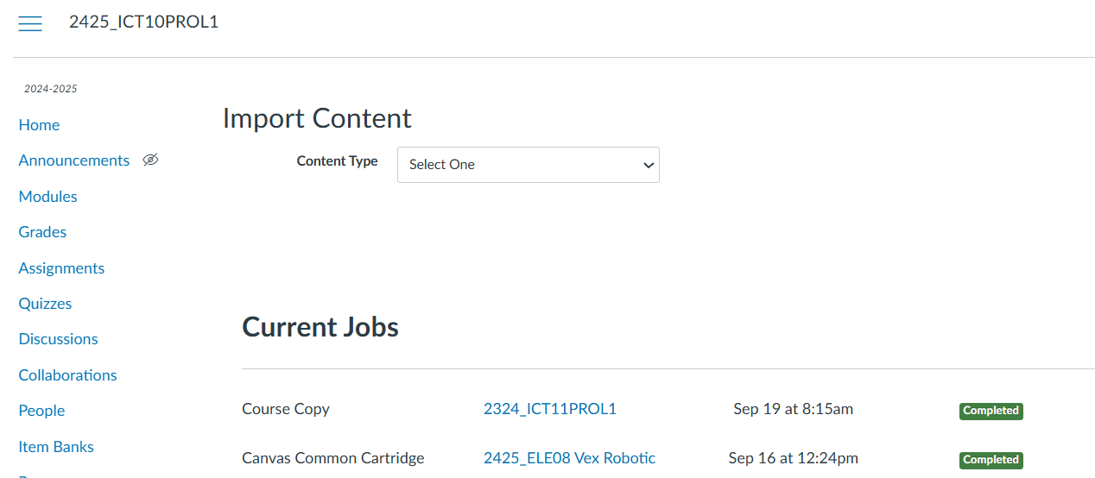
  - !Go to Settings > Import Course Content
  - Go to Settings > SCORM
  - Go to Settings > Quizzes
  - Go to Settings > Module
- What is the following interface for?
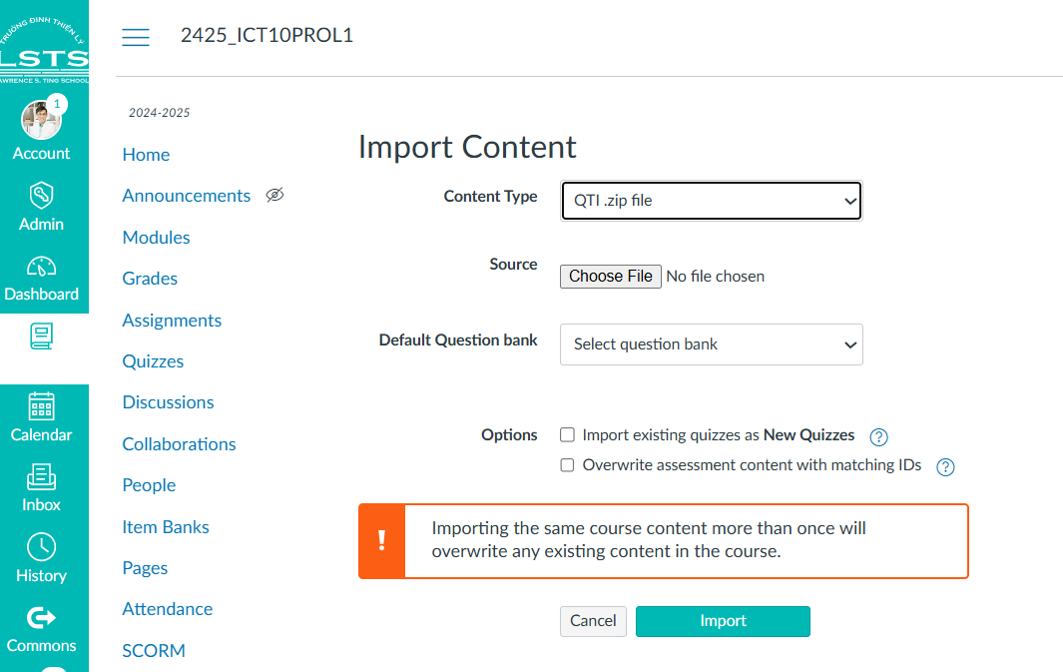
- ! Import Quiz as QTI.
- Copy content from one course to another
- Copy Module for different keys.
GROUP
Group title: Name of Group - This will be the name of the Item Bank on Canvas
pick: 1
points per question: 2
- Is it possible to replace the numbering of multiple-choice question answers from a) to a. true or false?
  - !Right
  - Wrong
- Does the question number need to be in the order of right or wrong?
  - !Right
  - Wrong
- Can the markup of the answer not need to be in the order of a, b, c, d true or false?
  - !Right
  - Wrong
- Is it possible to replace answer markers from normal characters to true or false uppercase characters?
  - !Right
  - Wrong
END_GROUP

